

|  |  |  |  |
| --- | --- | --- | --- |
| Kroonstate. H.J.E. Wenckebachweg 144 – 148 |  |  | Hva.nl |

Technical Design

Ver 1.0 - September 21, 2014

Contents

1. Project Goals 2
2. System architecture/infrastructure 2
3. 3
4. 4
5. 4
6. 4

# Project Goals

In agreement with our client we have set up several project goals that are supposed to be met at the finalization of the project. This project focusses on the main business goal: improving availability and reaching a bigger audience while retaining a bigger share or niche in the market of hosting services.  
  
This goal can be met if the project is divided in sub goals. The following topics are high priorities if it comes to meeting the expected product at the end of the project:

* Goal1
* Goal2
* Goal3
* Etc.

**Note**: aanvullen hierboven

# System architecture/infrastructure

The model for the network infrastructure is built with Archimate, a modelling software tool for enterprises. This model shows all connections and dependancies regarding the system that is built. This covers everything from customer activities to the software and hardware layer that connects the various software and programming structures we have designed.

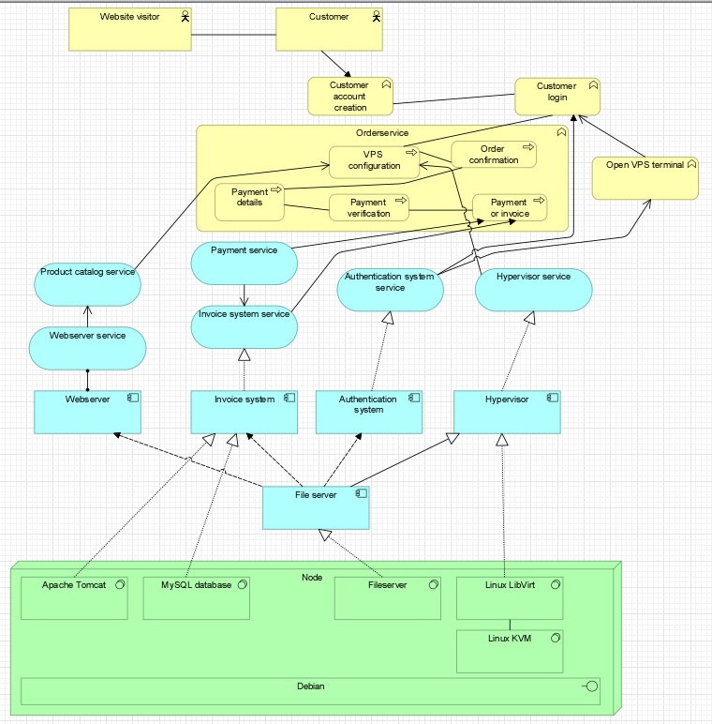

The model features several software and hardware inclusions, these are listed below. The model is divided in three layers:

**Businesslayer**Our model begins at the top with the entity ‘visitor’. This person can engage in the purchasing process and become a customer by creating an account and buying a product in the webshop (that is reached through a website). after a payment is processed the customer is now able to log in on the terminal and access their purchased hosting services.

* Method of contact
* Response time
* Representative’s level of knowledge

**Applicationlayer**

The top business level events are handled by several services in the applicationlayer which is a virtual layer connecting the business and the technical layer. There are four main services in the network:

* Payment service – handles payment
* Authentication service – authenticates users and admins for usage of the determined services
* Hypervisor service - authenticates admins to edit their services and grant authorization.
* Webserver service - presents customers and visitors with the product catalog

These services are essential for the businesslayer to work with the technical layer which we will discuss next.

**Technical layer**the technical layer is mostly based on a Dell server which runs a MySQL Database that stores all information regarding customer information and purchases. The server is also running a file server that stores all information for the four services running in the application layer.   
 The network infrastructure for the processing and running of the virtual machines that can be ordered by the customers is also maintained by the Dell server. The virtual machines are created by LibVirt and stored on the fileserver.